

**PCA 2**

**MAKAUT ODD SEMESTER 2024**

|  |  |
| --- | --- |
| **NAME:** | **RUPAK SARKAR** |
| **STREAM:** | **MCA** |
| **SEMESTER:** | **1ST** |
| **SUBJECT:** | **RELATIONAL DATABASE MANAGEMENT SYSTEM** |
| **SUBJECT** | **CODE: MCAN-192** |

**Q.1. Write a PL/SQL to print Hello World.**

Ans:

**SQL:** DECLARE

message VARCHAR2(20):= 'HELLO, WORLD!';

BEGIN

dbms_output.put_line(message);

END;

**Output:**

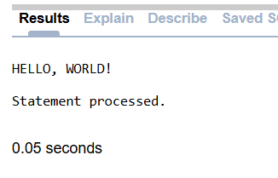

**Q.2. Write a PL/SQL program to find addition, subtraction, multiplication, division of two numbers.**

Ans:

**SQL:** DECLARE

A NUMBER(6);

B NUMBER(6);

S NUMBER(6);

SUB NUMBER(6);

M NUMBER(6);

D NUMBER(6);

BEGIN

A:=:A;

B:=:B;

S:=A+B;

SUB:=A-B;

M:=A*B;

D:=A/B;

DBMS_OUTPUT.PUT_LINE('SUM: '||S|| 'SUB: '||SUB||'MULTI: '||M||'DIV: '||D);

END;

**Output:**

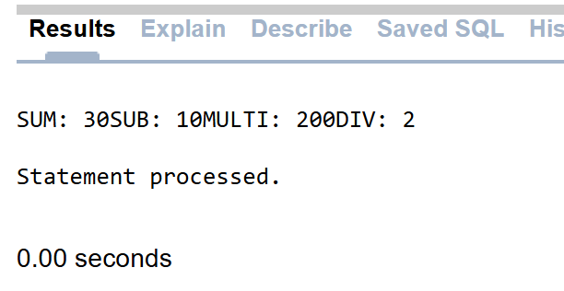

**Q.3. Write a PL/SQL program to print the maximum among three numbers.**

Ans:

**SQL:** DECLARE

A NUMBER(3); B NUMBER(3); C NUMBER(3);

BEGIN

A:=:A;

B:=:B;

C:=:C;

IF A>B AND A>C THEN

DBMS_OUTPUT.PUT_LINE(A||' IS GREATER THAN '||B||' AND '||C);

ELSE

IF B>C AND B>C THEN

DBMS_OUTPUT.PUT_LINE(B||' IS GREATER THAN '||A||' AND '||C); ELSE

DBMS_OUTPUT.PUT_LINE(C||' IS GREATER THAN '||A||' AND '||B); END IF;

END IF;

END;

**Output:**

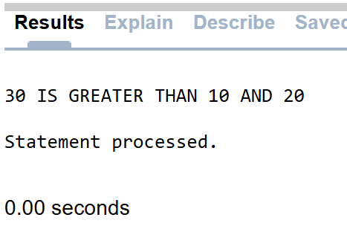

**Q.4. Write a PL/SQL program to print numbers from 1 -10 using different types of loop.**

Ans:

**SQL:** DECLARE

A NUMBER(6):=0;

BEGIN

LOOP

IF A>=10 THEN

EXIT;

END IF;

A:=A+1;

DBMS_OUTPUT.PUT_LINE(A);

END LOOP;

END;

**Output:**

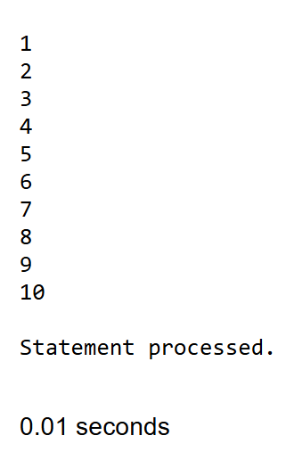

**WHILE LOOP:**

**SQL:** DECLARE

A NUMBER(6):=1;

BEGIN

WHILE A<=10

LOOP

DBMS_OUTPUT.PUT_LINE(A);

A:=A+1;

END LOOP;

END;

**Output:**

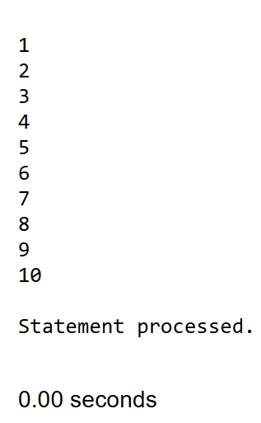

**FOR LOOP:**

**SQL:** DECLARE

A NUMBER(6):=0;

BEGIN

FOR A IN 0..10

LOOP

DBMS_OUTPUT.PUT_LINE(A);

END LOOP;

END;

**Output:**

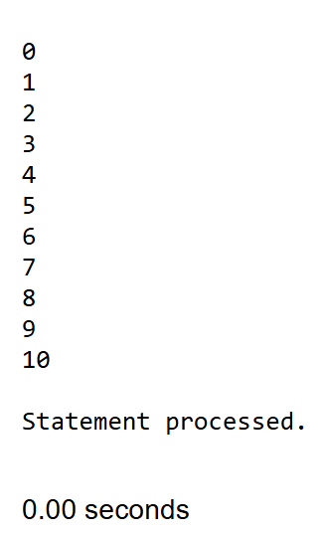

**Q.5. Write a PL/SQL program to calculate the area of a circle for a value of radius varying from 3 to 7. Store the radius and the corresponding values of calculated area in an empty table named AREAS consisting of two columns RADIUS and AREA.**

Ans:

**SQL:** DECLARE

PI CONSTANT NUMBER(4,2):=3.14;

V_RADIUS CIRCLE.RADIUS%TYPE;

V_AREA CIRCLE.AREA%TYPE;

BEGIN

V_RADIUS:=3;

WHILE V_RADIUS<=7

LOOP

V_AREA:=PI * POWER(V_RADIUS, 2);

INSERT INTO CIRCLE VALUES(V_RADIUS, V_AREA);

V_RADIUS:=V_RADIUS + 1;

END LOOP;

END;

**Output:**

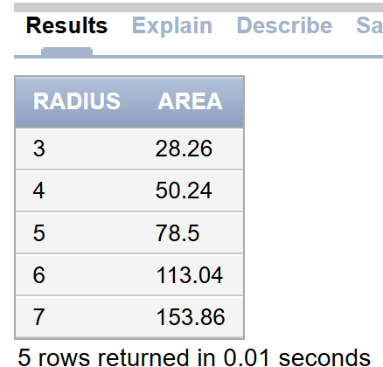

**Q.6. Write a PL/SQL program to Factorial of a number using function.**

Ans:

**SQL:** DECLARE

NUM NUMBER;

FACTORIAL NUMBER;

FUNCTION FACT(X NUMBER)

RETURN NUMBER

IS

F NUMBER;

BEGIN

IF X=0 THEN

F:=1;

ELSE

F:=X * FACT(X-1);

END IF;

RETURN F;

DBMS_OUTPUT.PUT_LINE(F);

END;

BEGIN

NUM:=6;

FACTORIAL:=FACT(NUM);

DBMS_OUTPUT.PUT_LINE('FACTORIAL '||NUM|| ' IS '||FACTORIAL);

END;

**OUTPUT:**

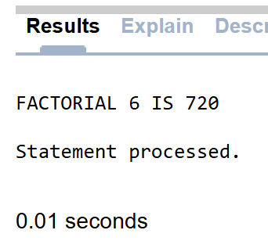

**Q.7. Print HELLO WORLD using Procedure.**

Ans:

**SQL:** CREATE OR REPLACE PROCEDURE GREETINGS

AS

BEGIN

DBMS_OUTPUT.PUT_LINE('HELLO WORLD');

END;

BEGIN

GREETINGS;

END;

**OUTPUT:**

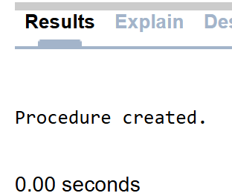

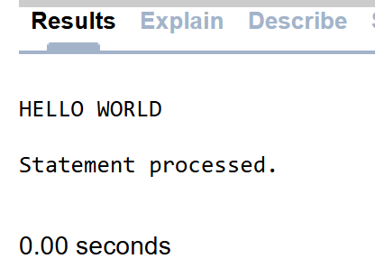

**Q.8. Write a PL/SQL script to create a table employee (emp_no, emp_name, salary, manager, dept_no). Write a program to create a row-level trigger for the employee table that would fire for INSERT or UPDATE operations performed on the employee table. This trigger will display the salary difference between the old values and new values.**

Ans:

**TABLE CREATION:**

**SQL:** CREATE TABLE EMPLOYEE(EMP_NO NUMBER, EMP_NAME VARCHAR2(50), SALARY NUMBER, MANAGER VARCHAR2(50), DEPT_NO NUMBER);

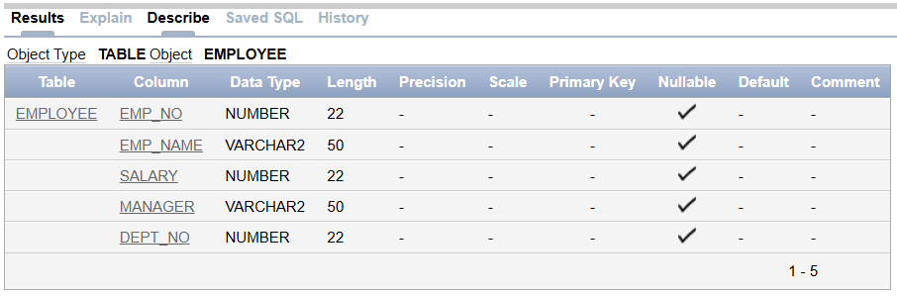

**VALUE INSERTION:**

**SQL:**

BEGIN

INSERT INTO employee VALUES(1001,'YYY5',18000,'AAA',20) ;

INSERT INTO employee VALUES(1003,'PPP5',20000,'BBB',10);

COMMIT;

END;

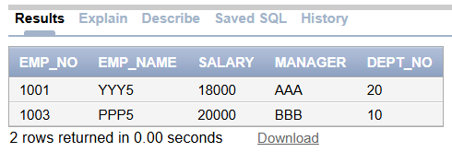

**TRIGGER CREATION:**

**SQL:** CREATE OR REPLACE TRIGGER salary_difference

BEFORE INSERT OR UPDATE ON employee

FOR EACH ROW

WHEN (NEW.emp_no > 0)

DECLARE

sal_diff number;

BEGIN

sal_diff := :NEW.salary - :OLD.salary;

dbms_output.put_line('Old salary: ' || :OLD.salary);

dbms_output.put_line('New salary: ' || :NEW.salary);

dbms_output.put_line('Salary difference: ' || sal_diff);

END;

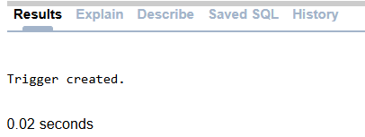

**TRIGGER CHECKING:**

**SQL:** INSERT INTO employee (emp_no,emp_name,salary,manager,dept_no)

VALUES(1005,'RRR5',30000,'BBB',10);

**OUTPUT:**

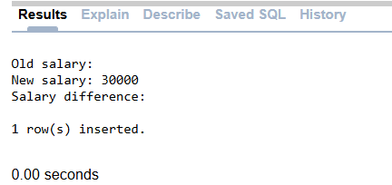

**SQL:** UPDATE employee

SET salary = salary + 500

WHERE emp_no=1003;

**OUTPUT:**

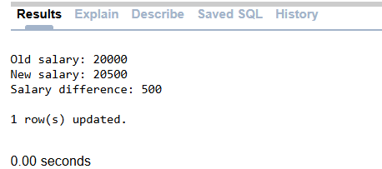

**Q.9. Write a PL/SQL script to print the details of the employee having the 2nd highest salary from employee table using explicit cursor.**

Ans:

**TABLE CREATION:**

**SQL:** CREATE TABLE EMP_EC(emp_no number(8),emp_name varchar2(10),salary number(8));

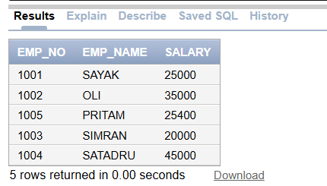

**CURSOR IMPLEMENTION:**

**SQL:** DECLARE

emp_no EMP_EC.emp_no%type;

emp_name EMP_EC.emp_name%type;

salary EMP_EC.salary%type;

CURSOR employee is

SELECT emp_no,emp_name,salary from EMP_EC

where salary = (select max(salary) from EMP_EC where salary <

(select max(salary) from EMP_EC));

BEGIN

OPEN employee;

LOOP

FETCH employee INTO emp_no,emp_name,salary;

EXIT WHEN employee%NOTFOUND;

dbms_output.put_line(emp_no||' '||emp_name||' '||salary);

END LOOP;

CLOSE employee;

END;

**OUTPUT:**

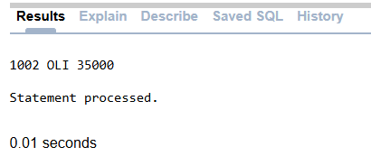

**Q.10. Write a PL/SQL script to implement Package.**

Ans:

**SQL:** CREATE OR REPLACE PACKAGE my_package AS

PROCEDURE greet(name VARCHAR2);

END my_package;

CREATE OR REPLACE PACKAGE BODY my_package AS

PROCEDURE greet(name VARCHAR2) IS

BEGIN

DBMS_OUTPUT.PUT_LINE('Hello, ' || name);

END greet;

END my_package;

BEGIN

my_package.greet('HEY THERE');

END;

**OUTPUT:**

